**DEPARTMENT OF INFORMATION TECHNOLOGY**

**Course Name and Code:** Data Structures Lab **(**ITL302)

**Semester:** III (SYIT)

**Academic Year:** 2024-25 (Odd Semester)

**Experiment No. 07**

**Aim:** Implementation of any one Graph Traversal Technique for rea1-world application

.

**Code:**

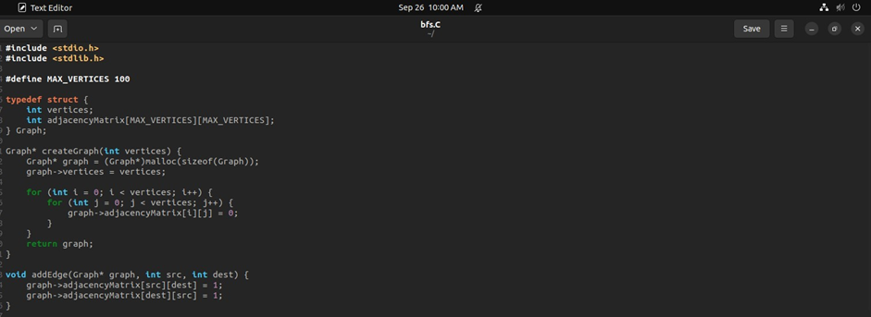

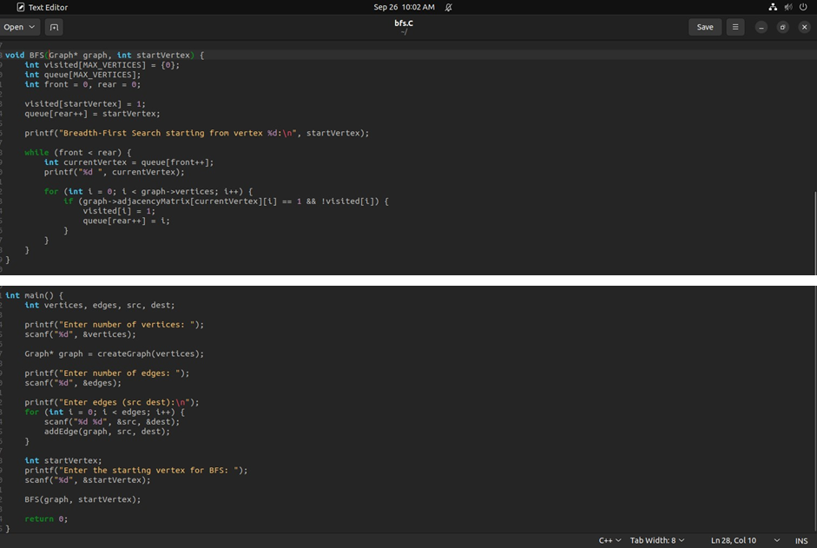

**Output:**

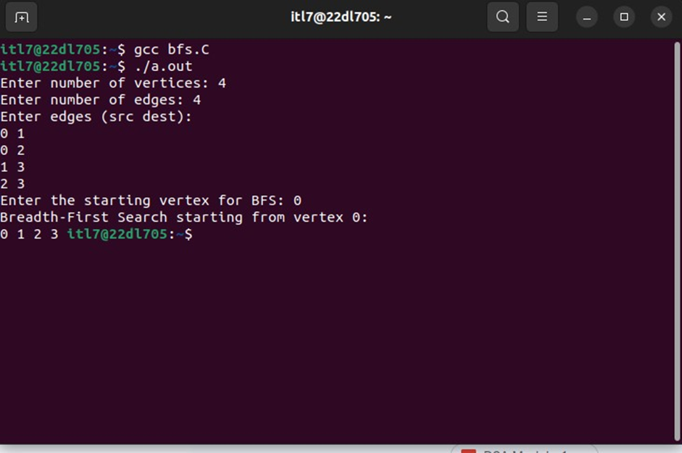

**Submitter Details:-**

**Name:** Veer Gokani

**Roll No:** 30

**Div/Batch :** A/ S-2